3.26: a) horizontal motion: 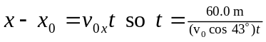
vertical motion (take 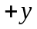 to be upward):
Solving these two simultaneous equations for  and t gives 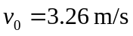 and 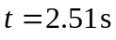.
b) 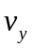 when shell reaches cliff:
The shell is traveling downward when it reaches the cliff, so it lands right at the edge of the cliff.

